Insert your photo below of the demand graph that you made for 2.1cp - Law of Demand

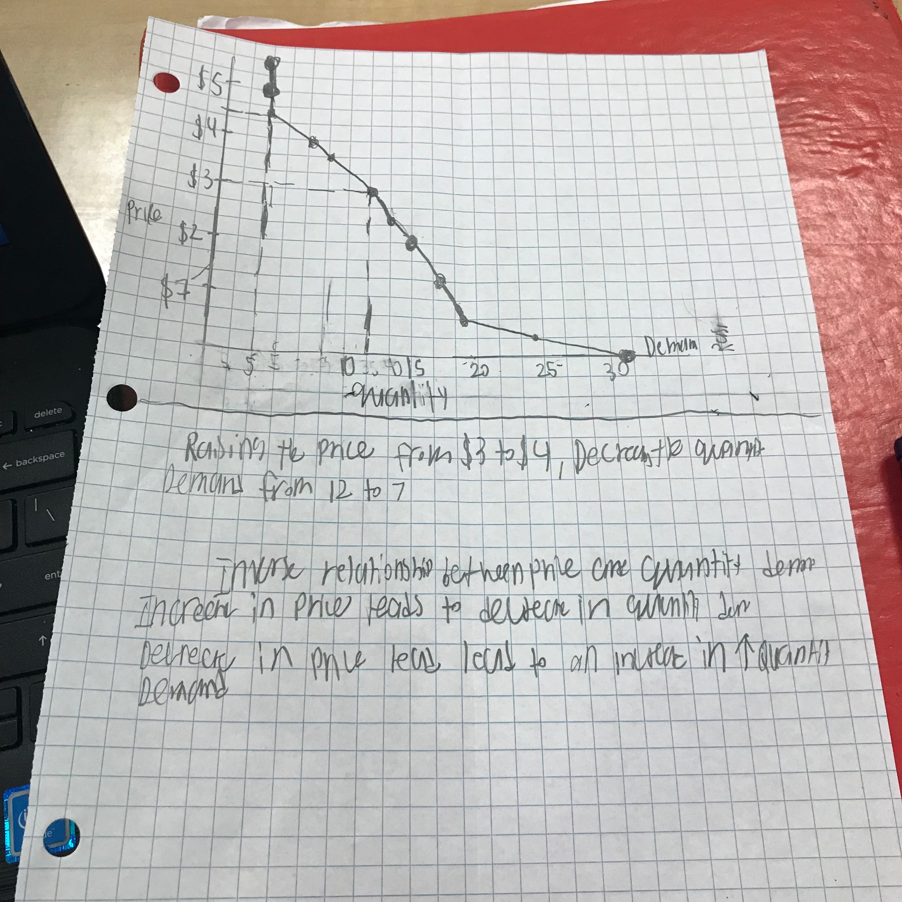

| What happens to the quantity demanded when price increases? | The quantity demand decreases when price increases |
| --- | --- |

| What happens to the quantity demanded when price decreases? | The quantity demand increases when price decreases |
| --- | --- |

| **The Law of Demand**: What is the relationship between price and quantity demanded? | The price of a product and the quantity demanded for that product have an inverse relationship, as stated in the law of demand. An inverse relationship means that higher prices result in lower quantity demand and lower prices result in higher quantity demand. |
| --- | --- |

3 Reasons For The Law of Demand

(Why price and quantity demanded go in opposite directions)

**The Substitution Effect**

| What is a restaurant that you eat at frequently? | Oceans and Earth |
| --- | --- |
| What do you order at that restaurant? | Free Range Turkey Burger |
| List 3 **other** restaurants that you would go to instead if your original restaurant **increased** their prices by 200% | 1. Apollo Greek Grill 2. Karma Lounge 3. Kenos |

| So what is happening to your quantity demanded for your original restaurant when you are going to the substitute restaurants more often due to the **price increase**? | An increase in quantity demanded is caused by a decrease in the price of the product (and vice versa). A demand curve illustrates the quantity demanded and any price offered on the market. A change in quantity demanded is represented as a movement along a demand curve. |
| --- | --- |

| What is the **Substitution Effect?** | Change in the combination of goods purchased as a result of |
| --- | --- |
| Explain how it reinforces the Law of Demand | Increasing or decreasing prices  At higher prices,people will substitute that product with cheaper substitutes |

**The Income Effect**

| What is the power of your income? | **The goods and services that it is able to purchase. The effect that increasing or decreasing prices have on the purchasing power of your income** |
| --- | --- |

| If you had $5, what items would you buy from the McDonald’s $1 Menu? | **Two Breakfast Burritos**  **One Sausage Biscuit** |
| --- | --- |
| What items would you buy if the $1 menu became the $.50 Menu? | **Four Breakfast Burritos**  **Two Sausage Biscuit** |
| What items would you buy if the $1 menu became the $2 Menu? | **One breakfast burrito** |

| What was happening to your willingness and/or ability to purchase when the prices went **up**? | **I tend to purchase a small quantity of the thing if thr prices go up** |
| --- | --- |
| What was happening to your willingness and/or ability to purchase when the prices went **down**? | **I tend to purchase a large quantity og the thing if thr prices go down** |

| What is the **Income Effect?** | **The effect that increasing or decreasing prices have on the purchasing power of your income** |
| --- | --- |
| Explain how it reinforces the Law of Demand | **At higher Prices, people’s incomes will be Able to buy Less.It's a fundamental economic principle that when supply exceeds demand for a good or service, prices fall. When demand exceeds supply, prices tend to rise. ... However, when demand increases and supply remains the same, the higher demand leads to a higher equilibrium price and vice versa.** |

**The Law of Diminishing Marginal Utility**

| Explain what **utility** is | Measurement of Usefulness or Satisfaction |
| --- | --- |
| Insert a photo of something that provides you with **a lot** of utility | Smart Money Definition |
| Insert a photo of something that provides you with **a little bit** of utility | Buy iPhone 11 - Apple |

| Explain what the word **marginal** means | Marginal in economics means having a little more or a little less of something. It refers to the effects of consuming and/or producing one extra unit of a good or service. Marginal benefit – is the change in total private benefit from one extra unit. |
| --- | --- |

Marginal Utility is the amount of satisfaction derived from 1 additional unit of a product

| **Slice of Pizza** | **Your Marginal Utility**  (Measured by how much you’d be willing to pay for it) |
| --- | --- |
| 1st Slice | $1.00 |
| 2nd Slice | $ 0.75 |
| 3rd Slice | $0.50 |
| 4th Slice | $0.35 |
| 10th Slice | Wouldn't pay |

| What is happening to your marginal utility as you get more and more slices of pizza? | My Marginal Utilitywill increase if i get more and more slices of pizza slices |
| --- | --- |

| What is the Law of Diminishing Marginal Utility? | The law of diminishing marginal utility says that the marginal utility from each additional unit declines as consumption increases. The marginal utility can decline into negative utility, as it may become entirely unfavorable to consume another unit of any product.As additional units of a product are consumed during a given period of time, the additional satisfaction derived from the good decreases.As you get more of something the less you are willing to pay and do more things for it |
| --- | --- |

When I eat any dessert, i feel less willing to finish and pay for the dessert

At higher quantities, people want it less and so they’ll be less willing to pay higher prices

| How does this reinforce the Law of Demand? | The price a consumer is willing to pay for a good depends on his marginal utility, which declines with each additional unit of consumption, according to the law of diminishing marginal utility. Therefore, the price decreases for a normal good when consumption increases.At higher quantities, people want it less and so they’ll be less willing to pay higher prices |
| --- | --- |